Code Review Process in TFS

WISEMAN INNOVATIONS
2340 East Trinity Mills Road Suite 250 Carrollton, TX 75006, United States



Certificate
Privacy Information
This document is the sole property of Wiseman Innovations and cannot be used for any other official, business, and personal means. All Rights Reserved @ Wiseman Innovations.
Copyrights
Wiseman Innovations has intellectual property rights relating to the substance that is described in this document. No part of this document may be reproduced or published in any form or by any means, without the express written permission of Wiseman Innovations. The User may view the content of this document on screen, print out copies or store electronically for personal use only as authorized and signed-on by Wiseman Innovations.
Acknowledgement
Data/ records shown in the document are used for illustrative purposes only and have no relation to original data; this data has been used solely to explain system functionality. Please enter original data in the system when using the system.

Document Change History
Document Version | Date | Developed By | Reviewer | Description of Changes
Initial Draft | 01-02-2018 | Owais Aized | Khurram Riaz | Initial Draft
V1.0 | 02-26-2018 | Khurram Riaz |  | - Text changed where required  - Text formatted where required

Contents
Certificate 1
Document Change History 1
1. Introduction 3
2. Code Review Request 3
Code Review before Check-in: 3
Code Review after Check In: 4
3. Responding to code review request 6
4. Update the code based on the review feedback 11

Introduction
Whenever you change a code in your application ask your peer or lead to review your code.
Microsoft allow us to review our code from someone else from our team.

Code Review Request
There are two type of techniques used to create code review request.
- Code Review before Check-in
- Code Review after Check-in

Code Review before Check-in
Using this techniques TFS create a temporary shelve in TFS and create a Review Request on it and send it to the selected team member.
These are the below steps to create Request Review before Check-in
- Request a Code Review
After completing development on task before check in Team Explore window you have an option to generate a review request.
- Click Request Review
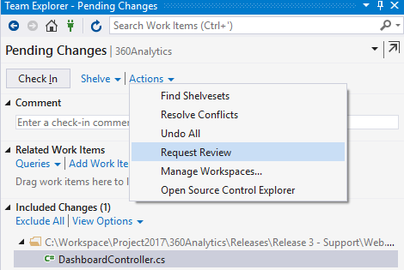

- Add reviews of request and submit request
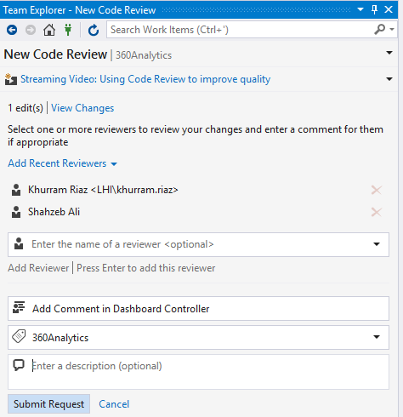

Code Review after Check In
This mechanism will be only used by support team. Support team can create a code review request after check-in to support branch. After review approval from dev team code will be checked-in to main branch.
Select any previous check-in from Source control History view and generate Request Review from there.
- Right click any change set and click Request Review.
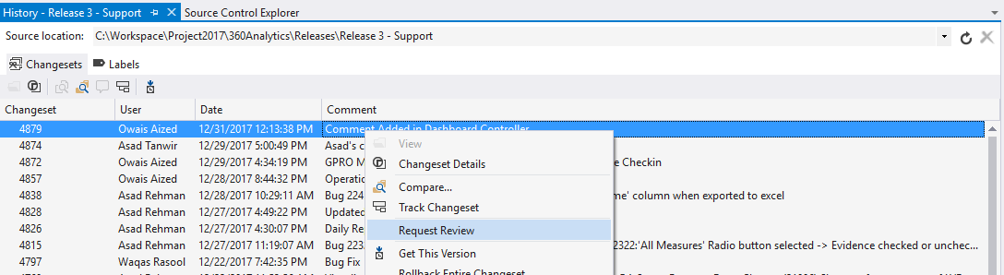
- Add reviews of request and submit request

Responding to code review request
Reviewer will see the code review request in the team explorer, look at the changes, and give Requester his feedback.
- Reviewer opens My Work page.
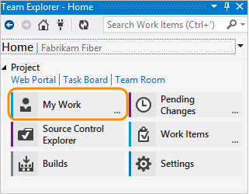
- He sees Requester's code review request at the bottom.
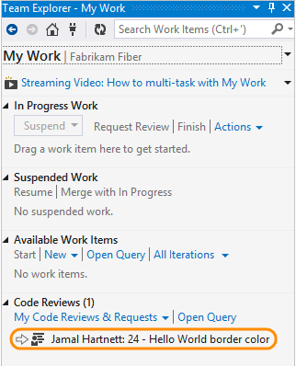
You can get email alerts for code reviews, too. If you aren't getting them, you can sign up in the team explorer settings page.
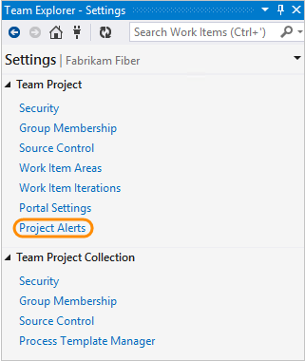
- Reviewer opens the code review request.
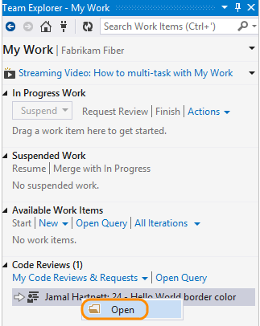
- He Accepts or Decline the review.
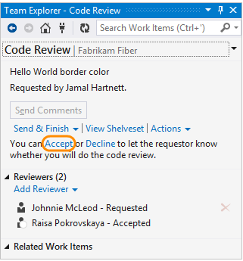
- He opens the file that Requester changed.
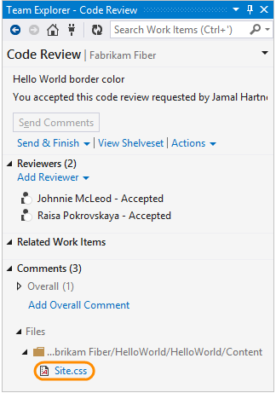

- Reviewer sees that requester changed the color to #ddd. He selects the code in the difference window and adds a comment (Keyboard: Ctrl + Shift + K).
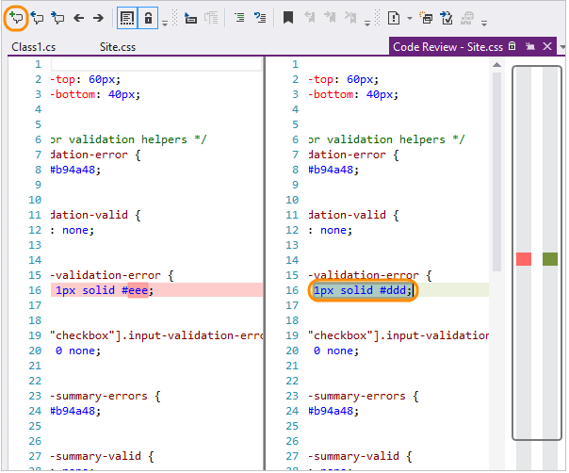

- He suggests a different color instead and sends the comment to requester.
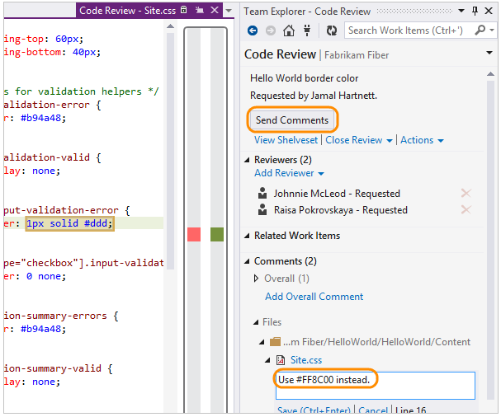

Update the code based on the review feedback
- When Requester gets a response from Reviewer, he resumes the work on Hello World.
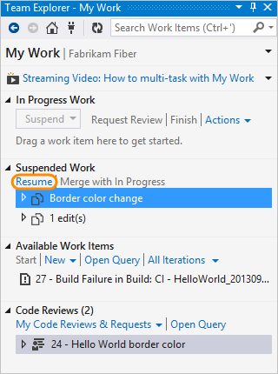

- His changes are un-shelved and the windows he had opened are restored, so he can incorporate the review feedback.


